 | 2025 PGSG PRECONFERENCE  Updated 2/17/25  University of Michigan  & Michigan State University  Saturday, March 22, 2025  UM – Detroit Center  3663 Woodward Ave #150

Overview
All times are Eastern Standard Time (GMT-4)
8:00-8:30 Check-In/Registration [A light, limited breakfast will be provided on Saturday, courtesy of UM SEAS. See p. 3 for suggestions on heartier options.]
8:30-8:45 Opening Comments/Welcome [Flint Room]
8:45-10:15 Sessions I, II, III
10:15–10:30 Break
10:30–12:00 Sessions III, IV, V
12:00–1:15 Lunch Break (on own; suggestions on page 3)
1:15–2:45 Sessions VI, VII, VIII
2:45–3:00 Break
3:00–4:30 Sessions IX, X, XI
4:30–4:45 Closing Comments [Flint Room]
5:00–8:00 PGSG Dinner (optional; registered participants only), Location to be announced
ADDITIONAL EVENTS
- Sunday, 3/23, 9:00 AM - 1:00 PM: D-Tour (registered participants only)
- Monday, 3/24, 10:10 AM - 11:30 AM: Brunn Early Career Lecture (Galen Murton), 430B, Level 4, Huntington Place
- Tuesday, 3/25, 11:40 AM - 12:40 PM: PGSG Business Meeting, 411C, Level 4, Huntington Place

Registration, Cost, Contact Information, & Directions
REGISTRATION
Register by February 20, 2025 using the form here (also available via the PGSG website): https://docs.google.com/forms/d/e/1FAIpQLSe1qjUgBhYjJAsutYvZDQ1gr7iZzBlcAU0JR8CBCntfiN-VBQ/viewform?usp=sf_link

COST
Saturday Paper Sessions: There is a $25 fee for tenure-track faculty only.
- Electronic Payment (strongly preferred): Please pay in advance via the AAG’s electronic payment site using the following process:
  - Submit your payment via the AAG’s Political Geography Specialty Group site here (https://www.aag.org/groups/political-geography/).
    - Click “Donate.”
    - Ensure that “Political Geography Specialty Group” is listed under “Fund.”
    - Please write “Preconference” in the “In Honor/Memory Of” section.
    - Include your full name and contact information.
  - You will receive a receipt from the AAG via email.
  - Please maintain a printed or digital copy of your receipt (or screenshot). You will be asked to confirm your payment at event check-in.
- Cash or alternative (only if necessary): Please contact Meredith (deboom@mailbox.sc.edu) to make alternative payment arrangements. If using cash, be sure to bring exact change.

Sunday D-Tour: Space limited; advance registration required. There will be a fee for all participants (details to be finalized and communicated, likely ~$45-50). Once you have received email notification from the organizers that you have a seat, please follow the payment instructions above and then upload your receipt to https://docs.google.com/forms/d/e/1FAIpQLSeDyedqh-u4yGc6ZwObKu6eChsQSD1JyBBBWgF7DChzFcXjfw/viewform?usp=sharing by March 1 to confirm your seat. After March 1, unconfirmed seats will be re-allocated to participants on the waitlist.

CONTACT INFORMATION
Organizers (contact with any questions)
- Meredith DeBoom, PGSG President (University of South Carolina; deboom@mailbox.sc.edu) and Kate Coddington, PGSG Vice President (University at Albany, SUNY; kcoddington@albany.edu): Contact with pre-conference, paper session, or general questions
- Jessi Quizar (University of Washington-Tacoma; jquizar@uw.edu) and Jamaal Wright (University of Florida; wrightw@ufl.edu): Contact with D-Tour questions

Thank you to our local hosts!
- Katie Brown, Mehmet Eroğlu, and Dr. Kyle Evered, Dept. of Geography, Environment, and Spatial Sciences, Michigan State University
- Dr. Bilal Butt, School for Environment and Sustainability, University of Michigan
Thank you to our sponsors!
- Black Ecologies Lab (Rutgers; Drs. J.T. Roane and Teona Williams)
- Environment and Planning C: Politics and Space
- Luskin Institute on Inequality and Democracy (UCLA; Dr. Ananya Roy)
- Political Geography Specialty Group (AAG)
- School for Environment and Sustainability (SEAS), University of Michigan (via Dr. Bilal Butt)

Conference Wifi Access and Dining Suggestions
Saturday, UM Detroit Center: MGuest (open a webpage in your browser; you will be directed to a login page) or Eduroam (if you have access at your home institution)

Breakfast & Coffee/Tea: There will be a light, limited breakfast (e.g., coffee, tea, muffins) available on a first-come, first-serve basis on Saturday. The following businesses are convenient to the pre-conference location and provide heartier options:
Qargo Coffee (3670 Woodward Ave)
Kitab Cafe (422 W Willis St)
Effin Egg (4160 Cass Ave)
Honest John's (488 Selden St)
Avalon on Canfield (441 W Canfield St)
For the Love of Sugar (100 Erskine St)

Lunch: Lunch is on your own. The following businesses are convenient to the pre-conference location:
Detroit Shipping Company (474 Peterboro St)
The Peterboro (420 Peterboro St)
Rocco's Italian Deli (3627 Cass Ave)
Pho Lucky Detroit - Midtown (3111 Woodward Ave)
Jolly Pumpkin Pizzeria & Brewery (441 W Canfield St)
Condado Tacos (634 Selden St Suite A)

DIRECTIONS
The preconference will be held at the University of Michigan Detroit Center—3663 Woodward Ave #150, Detroit, MI 48201.
Public Transportation (recommended)
- The Q-Line Streetcar (free; https://www.qlinedetroit.com/) offers transportation along Woodward Ave from downtown Detroit.
  - For those staying at/near the AAG hotel: board the Northbound line at the Congress St. Station (0.4 miles/~10-minute walk from the Marriott) and disembark at the Mack Avenue Station (~0.1 mile to UM Detroit Center).
- You may also consider using the People Mover light rail (free; (https://www.thepeoplemover.com/).
  - For those staying at/near the AAG hotel: board at the Renaissance Center Station and disembark at the Grand Circus Park Station (roughly 0.7-1mile/~20-minute walk south of UM Detroit Center).
- You can also find bus routes through DDOT (https://detroitmi.gov/departments/detroit-department-transportation/bus-schedules).

Parking
- Limited, metered street parking is available on side streets.
- Public Parking Garage near UM Detroit Center: DSO Parking Deck (81 Parsons St., between Woodward and Cass); be careful not to park in a reserved spot!

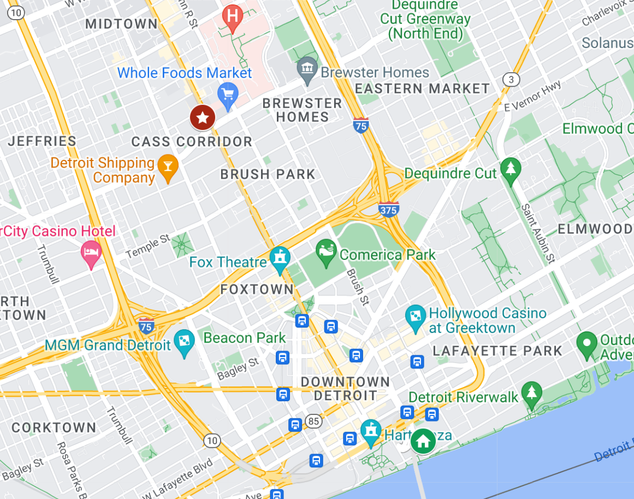
Saturday—Paper Sessions
University of Michigan Detroit Center
3663 Woodward Ave #150

AAG Hotel (Renaissance Center Marriott)

SATURDAY - SESSION THEMES AT A GLANCE
Room | Flint | Dearborn | University
8:30  -  8:45 | Opening Remarks (Flint Room)
8:45  -  10:15 | I = Disciplinary identities | II = Building commons, building community | III = Humanitarian and post-conflict responses
10:15  -  10:30 | Break
10:30  -  12:00 | IV = Border enforcement | V = Energy, conflict, and climate change | VI = Colonialism, knowledge, and anti-colonial practices
12:00  -  1:15 | Lunch
1:15  -  2:45 | VII = Border theories and thinking | VIII = Environmental justice and the city | IX = Eurasia - Knowledge making
2:45  -  3:00 | Break
3:00  -  4:30 | X = Geopolitics and violence | XI = Abolition and liberation thinking | XII = Eurasia - Infrastructure
4:30  -  4:45 | Closing Remarks
5:00  -  8:00 | Dinner

NOTES:
- Paper presenters should limit their presentations to 15 minutes. A total of 15-30 additional minutes will be provided for discussion, either broken into short segments after individual papers, or collectively assessing the papers after they conclude (at chair’s discretion).
- Please have presentation slides available on flashdrive or be prepared to present from your laptop.
- Abstracts for each paper are available on the Political Geography Preconference website.

8:45-10:15 Session I: Disciplinary identities
Chair: Kevin Grove, Florida International University

Presented and Published: Topics at the Political Geography Specialty Group Conference, Benjamin Forest (Department of Geography, McGill University)

Revisiting the Political Ecology/Geography Interface: Trends, Progress, and Future Directions, Bilal Butt (School for Environment and Sustainability, University of Michigan) and Meredith DeBoom (Department of Geography, University of South Carolina)

Remembering Bunge’s Detroit Geographical Expedition: Implications for the ‘Global South’ Trope, Alexander (Alec) Murphy (Department of Geography, University of Oregon)

Worlding Geography: decolonizing our discipline by better bridging language gaps, Sara Koopman (Kent State School of Peace and Conflict Studies)

8:45-10:15 Session II: Building commons, building community
Chair: Karen Culcasi, West Virginia University

Empowering Change: Refugee Agency in Grassroots Advocacy Organizations, Kara E. Dempsey (Department of Geography and Planning, Appalachian State University)

Recuperating democratic institutions for territorial defense and self-determination in Mexico, Fiona Gladstone (Fairleigh Dickinson University) and Bia'ni Madsa' Juarez Lopez

Housing Commons: Challenging Intersectional Disparities and Housing Precarity, Brenda Parker (University of Illinois at Chicago) and Isobel Araujo, (University of Illinois Chicago)

Youth Distrust and Agency: Florida Curricular Debates, Civic Empowerment Gap, and Study Abroad, Jessica Flach (Department of Geography, University of South Carolina)

8:45-10:15 Session III: Humanitarian and post-conflict responses
Chair: Reece Jones, University of Hawai’i at Manoa

Smokescreens and Strangleholds: How Host Governments Obstruct Humanitarian Response, Anne Della Guardia (International Relations Department, London School of Economics & Political Science)

Humanitarian geographies of migrant return: Assisted Voluntary Return and Europe's migration ‘crises’, Austin Crane (Walker Institute of International & Area Studies and Department of Geography, University of South Carolina)

Slow Sacrifice Zones?: Rural post-conflict landscapes and explosive risk, Ruth Trumble (Department of Global Studies and Geography)

The "Land Question" in the Russian Geopolitics of Territorial Occupation, Vera Smirnova (Department of Geography and Geospatial Silences, Kansas State University)

10:30-12:00 Session IV: Border enforcement
Chair: Kenneth Madsen, Ohio State University

Spanish Border Externalization & The Necroborder, Fernando Lopez Oggier (University of Hawai'i at Manoa)

Manufacturing desolation: undocumented border crosser mortality and the sociopolitical construction of remoteness in United States boundary enforcement, Geoff Boyce (School of Geography, University College Dublin) and Daniel Martínez, Tara Plath, Sam Chambers

Malicious compliance: How Rights-Based Frameworks Have Enabled the Development of Border Technology, John Nightingale (Geography and Environment, University of Hawai'i at Manoa)

Refugee Camp Territories in Jordan, Karen Culcasi (Department of Geology and Geography, West Virginia University)

10:30-12:00 Session V: Energy, conflict, and climate change
Chair: Ruth Trumble, Hofstra University

Contested mineral ecologies: Mining formalization, ethnic communities and territorial struggles in Chocó (Colombia) and Madre de Dios (Perú), Gisselle Vila Benites (Global Development, Cornell University)

Mining Their Own Business: Everyday Power Struggles Between Informal Miners and State Officials in Turkey, Mehmet Eroğlu (Department of Geography, Environment, and Spatial Sciences, Michigan State University)

The Proliferation of National Security: renewable energy technology in the U.S., Lindsay Naylor (Department of Geography & Spatial Sciences, University of Delaware)

Unlocking the Hidden Vault: Harnessing the Power of Untapped Government Data for Safeguarding Biocultural Diversity in Mexican Maize or Government Data and Biocultural Diversity in Mexican Maize, Jimena de la Fuente Ramirez (Genética de la Conservación, Jardín Botánico, Instituto de Biología, Universidad Nacional Autónoma de México, Ciudad de México, México and School for Environment and Sustainability, University of Michigan, Ann Arbor, MI, United States; Laboratorio Nacional de Ciencias de la Sostenibilidad, Instituto de Ecología, Universidad Nacional Autónoma de México, Mexico City, Mexico) and Javier Pérez-Lópeza; Leonardo Calzada; Gonzalo Martínez-Herrera; René Cerritos; Valeria Alaveza; Ana Wegier.

10:30-12:00 Session VI: Colonialism, knowledge, and anti-colonial practices
Chair: Mark Ortiz, Penn State University
Race and the British Colonial Imaginary, Gerry Kearns (Department of Geography, Maynooth University, Ireland)

The decolonization and feminization of pre-field missionary training, Jill Thornton (Department of Geography, University of South Carolina)

Anentaim-Sa-Tin-Nunka (Thinking Earth) for planetary health: Listening to Mother Earth's Wisdom through Indigenous Shuar Science, Martina Jakubchik-Paloheimo (Department of Geography and Planning, Queens University) and Shuar Kakaram de Buena Esperanza

Climate Extremes, Civil Unrest, and Natural Resource Extraction: Understanding Multiple Exposures in Sofala and Gaza, Mozambique, Lauren Herwehe (Department of Geography, University of Colorado Boulder)

1:15-2:45 Session VII: Border theories and thinking across borders
Chair: Benjamin Forest, McGill University

The corridor is a positive space that eliminates the negative space of the frontier: security and development contemporary Tibet, Andrew Grant (University of Tampa)

The Art of Not so Being Governed: Territory and Citizenship for the Nepalese Bianmin across the Liminal Himalayan Borderscapes, Baichuan Liu (Department of Geography, Durham University)

Walking Alongside: The Hot Girl Walk, Devika Ranjan (Performance Studies, Northwestern University)

An Adornian Critique of Categories, Borders and Boundaries, Daniel Rogers (CUNY Graduate Center)

1:15-2:45 Session VIII: Environmental justice and the city
Chair: Brenda Parker, University of Illinois - Chicago

One-Dimensional Climate: Los Angeles at the Crossroads of Climate History, Benjamin Weinger (Department of Geography, University of California, Los Angeles)

Fantasies, Fabulation, and Phantoms in the ‘Magic City’: A Hauntology of Environmental Injustice in Birmingham, Alabama, Mark Ortiz (Department of Geography, Penn State University)

Humans and concrete in Albuquerque's International District, Ramona Malczynski (Department of Geography and Environmental Studies, University of New Mexico)

Urban Water Quality and the Racialized Politics of Socio-Ecological Reproduction in Detroit, Nicole Van Lier (Schulich School of Law, Dalhousie University)
1:15-2:45 Session IX: Eurasia - Knowledge making
Chair: Megan Dixon (The College of Idaho) and Ariel Otruba (Virginia Tech Institute for Policy and Governance and Arcadia University)

Geographies of Resistance: Kurdish Autonomy and the Politics of Land in Rojava and Bakur, Dillon Foster (School for Environment and Sustainability, University of Michigan)

Albazino across Narrations and Imaginations: A Comparative Spatial History of a Far Eastern Eurasian Borderland, Liao Zhang (Global Perspectives on Society Postdoctoral Program, NYU Shanghai)

Contesting Eurasia: Independent Spatial Knowledge and Post-Soviet Legacies in Georgia and Tajikistan, Dr Sofia Gavrilova (Leibniz Institute for Regional Geography)

Building Socialism, Synthesizing Eurasianism: The 1934 Ferdowsi Millennium in the Soviet Union, Diego Benning Wang (Department of History, Kean University)

3:00-4:30 Session X: Geopolitics and violence
Chair: Kara Dempsey, Appalachian State University

Violent Confluence of Peace and Geopolitics in the Pacific, Tatsuki Kohatsu (Department of Geography and Environment, University of Hawaiʻi at Mānoa)

The Reconfiguration of Geopolitical Imaginations in Times of Rupture. A Critical Geopolitical Analysis of Political Debates in the German Bundestag on the Russian War against Ukraine, Lilly Anjana Lautermann (University of Muenster) and Prof. Dr. Paul Reuber

A critical reflection on tourism geopolitics: research progress and future agenda, Yan Huang (Geography School, South China Normal University) and Yungang Liu

The Dictator’s Rocketeer: Lutz Kayser and His Extraordinary Dream of Commercial Spaceflight, Chase Womack (Department of Geography, Environment, and Sustainability, University of North Carolina at Greensboro) and Corey M. Johnson

3:00-4:30 Session XI: Abolition and liberation thinking
Chair: Sara Koopman, Kent State University

Border Walls and Mass Incarceration, Kenneth Madsen (Department of Geography, The Ohio State University at Newark)

Expanding horizons: Closing toxic prisons and a just transition, Sonja Dahl (Department of Geography, Environment, and Urban Studies, Temple University) and B. Preston Lyles (Toxic Prisons Campaign, Human Rights Coalition)

Placing the Global Struggle for Black Liberation in East Tennessee, LaToya Eaves (Department of Geography & Sustainability, University of Tennessee, Knoxville) and Brian Boyce, Gabrielle Chapman, Caleb Gore, Annie Liu, Lutfiyah Madyun, Mary McMillan Terry, Cole Thornton, Anne Victoria, Margaret Walton

Municipal Planning and Migrant Inclusion: A Comparative Case Study between Detroit MI, New York and Sao Paulo, Brazil, Omawu Diane Enobabor (Earth and Environmental Studies, CUNY Graduate Center)

3:00-4:30 Session XII: Eurasia - Infrastructure
Chair: Kate Shields (Rhodes College) and Evangeline McGlynn (Harvard University)

Bare life Resistance: Emerging Oppositions to China in the Global South, Davide Giacomo Zoppolato (West Virginia University, USA)

From Tianxia to Huoban: Transnational Embeddedness and the Remaking of China’s Neighborhood Diplomacy in Asia, Xiaobo Su (Department of Geography, University of Oregon)

Revisiting the Geographies of Obdurate Infrastructure in Eurasia, Corey Johnson (University of North Carolina at Greensboro)

Penetration of Light: The Intersection of Border and Light in the 21st Century, Kai-Yang Huang (Department of Geography, National Taiwan University)

